Block Diagram:

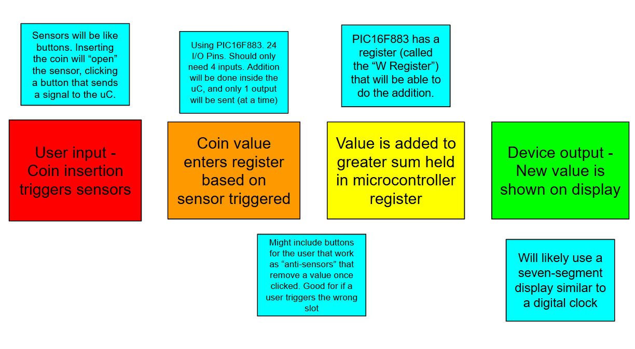

Device size: 6in x 6in x 4.5in

Slot count: 4

Microcontroller: PIC16F883

Display: Seven Segment LED Display

Material: Unknown. Will need to check what the Makerspace has available and compare cost with durability. The chosen material won’t be under too much stress, so wood could be an option?